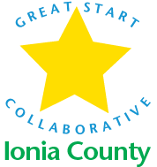

FAMILY & WELLNESS COMMITTEE MINUTES
11-16-2017

- Welcome and Introductions
  - What was your worst job?

- Goals
- Back to School Event
- Social Workers
- Diaper Drive

- Round Table

- Wrap up – Next Steps, Timelines, Individual Responsibilities

Next Meeting: Next meeting January 17, 2018 9:30 am
Flat River Conference Room Ionia ISD

