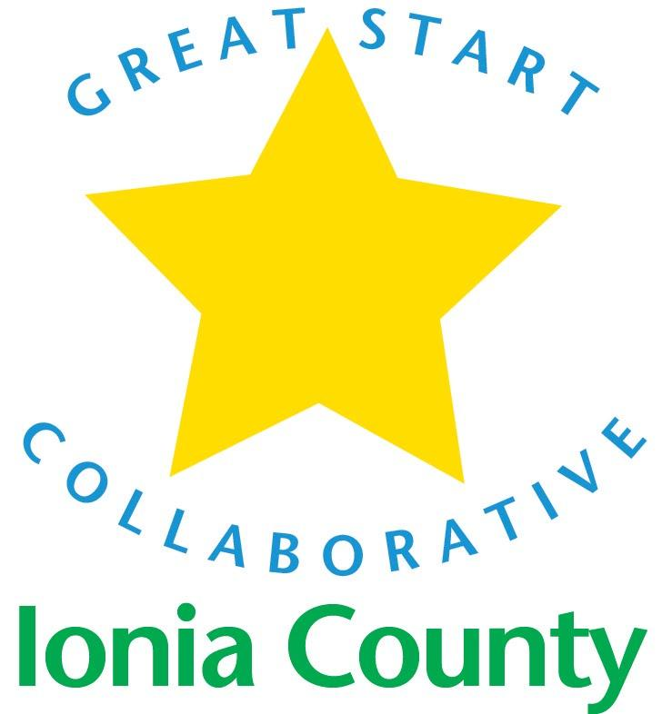

Ionia County Great Start Collaborative Minutes
3/13/18
12:30 Lunch and Networking
1:00 Full Board Meeting
@ Ionia County Intermediate School District

Present: Ken Bowen (Ionia County Health Dept), Alese Evon (8Cap), Amber Gibson (DHHS), Cheryl Granzo (Early On), Claire Hopkins (RAVE), Sally Kapteyn (ICGSC), Lori Brasic (Great Start to Quality), Jessica Murphy (ICGSC), Amy Opperman (GSRP), Molly Perez (The Right Door), Jason Smith (Saranac Community Schools), Melissa Stevens (8Cap), Jason Mellema (Ionia ISD), Wanda Zenk (PSIC)

- Welcome & Introduction
Are you spring, summer, fall, or winter? Please share why.

- Approval of Minutes - Claire motioned to approve and Sally seconded, all in favor

- Featured Agency
- Positive Solutions Informed Choices - PSIC is a non-profit Christian Mission that offers pre-pregnancy testing, options counseling, educational classes, and will soon offer on site ultrasounds.
  - They work to support the family, and a working to offer more fatherhood support.
  - They also have an onsite Baby Boutique, where families can spend the “baby bucks” they earn by taking classes to purchase diapers, clothes and other supplies.
  - Recently moved into a new space at 330 Lovell in Ionia and are hoping to offer more classroom and group classes.
  - They do one on one consultation with expectant mothers, usually every other week, deciding on classes together and the mother receives a layette at the end of her pregnancy.
  - PSIC is funded through business donations, volunteers, etc.
  - 99 families served last year, 120 the year prior. The drop is likely due to the implementation of “baby bucks”.

- Director Report - Data on Childcare in Ionia County - See Handout

- No one is specifically working on the issue of childcare in Ionia County.
- Part-time and after 5 PM care is super limited
- Lori Brasic mentioned families members or friends who provide care in the child’s home can receive the subsidy if they fill out the application and do a one day training.
- Build up Michigan is child find for children of school age who is suspected to have a disability.
- Committee Reports
- Parent Coalition: Jessica Murphy - The next Family Fun Night is April 17th. The Parent Core Group is meeting regularly and working on the Parent Led Strategies, a Parent Child Dance and Sharing Table.
- Early Education & School Advisory: Amy Opperman
  - The next meeting is is March 27th.
  - The group is working on the Kindergaten Transition Packs.
    - New sponsors are Ionia County Community Fund, TriCounty, and PFCU.
    - They will be distributed at Kindergarten Round ups in each of the local districts.
  - The State is mandating a new Kindergarten Readiness Assessment to be done within the first 30 days of Kindergarten, starting in the Fall of 2018. Most of the assessment is done through observation and on tablets.
  - The Joint Recruitment application is out, and GSRP and Head Start are working on distributing. To start children need to be 4 by September 1st. After September 1st they will be able to take children who are 4 by December 1st.
    - They will be advertising using yard signs and postcards, and foregoing billboards this year.
- Family Support and Wellness -
  - Spring into Safety is scheduled for May 12th from 2-4 at Ionia High School. Activities include:
    - Touch a Truck
    - Bike Activities and raffe
    - Teddy Bear Clinic
    - Goody bags
    - and much more
- Executive Committee – Molly Perez - nothing new to report

- Round Table Updates
- Claire Hopkins - RAVE - April is Sexual Assault Awareness Month, they will be “Painting the Town Teal”, handing out ribbons, setting out yard signs, etc. The “Battle of the Badges” fundraiser is April 28th from 5-8, pitting Police and Fire in a basketball game.
- Ken Bowen - Health Department - The flu seems to be leveling off, but is still elevated. Hep A is escalating and they are getting prevention funding from the State. Anyone who might be affected can go and get the vaccine. They are also looking for WIC clients.
- Cheryl Granzo - Early On - DPIL quilt raffle is coming up, Cheryl has tickets. Sparrow Gala is Saturday April 28th, and DPIL will get half of the donations. There will be a fundraiser over Spring Break at the Ionia Bowling Alley.
- Wanda Zenck - PSIC - Fundraising Banquet on April 26th, and Benefit Sale on April 7th.
- Amber Gibson - DHHS- April is Child Abuse Prevention Month and the ICAN Picnic is April 24th at 11 AM. There is a new Bridges app, it is more user friendly.
- Melissa Stevens - 8 Cap - Wrapping up the 17-18 school year, ramping up for 18-19. Looking to recruit for Early Head Start. will now be housed in Midland as the Office of Young Children is closing. Contacts are staying the same.
- Molly Perez - The Right Door - Community Drug Training Friday, March 16th from 9-11, open to all professionals.
- Sally Kapteyn - ICGSC - Save the date for our Trauma Training August 20th.

Next Meeting Date: May 8, 2018

Community Events

March 17 - I am Safe Fundraiser
March 24 Day of Music- Portland
March 31 - Lakewood Easter Event
April 14 - Mom to Mom Sale, Ionia
April 21 - United to End Hunger
April 28 - Sparrow Charity Ball
April 28 - Belding Expo
May 12 – Spring into Safety
May 19 - Portland Block Party
July 17, 2018 Kids Day
August 20, 2018 - Trauma Training – Dr. Stephanie Grant
8am-3pm Open County Wide
6:pm – 7:30 pm Parents and Providers

Kindergarten Round-ups

Portland April 12th & 13th
Saranac - April 14th
Belding - April 24 & 26th
Ionia - April 18 & 25 May 22 & 29
Lakewood - May 8 & 9

